# Data Structures and Algorithm

# Assignment-1

Name-Harsh

Roll_no-1024030497

Batch-2C25

Ques-1)

#include <iostream>

using namespace std;

const int MAX = 100;

int a[MAX];

int n = 0;

void create() {

cout << "create your array"<<endl;

cout << "How many elements would you like to add? ";

cin>>n;

for (int i = 0; i < 1

n; ++i) {

cin >> a[i];

}

}

void display() {

cout<<"your entered aay is:"<<endl;

for (int i = 0; i < n; ++i) {

cout << a[i] << " ";

} cout << "\n";

}

void insert() {

int pos, val;

cout << "Enter the position where you wish to add value and the value"<<endl;

cin >> pos>>val;

for (int i = n; i > pos; i--) {

a[i] = a[i - 1];

}

a[pos] = val;

n++;

cout<<"value inserted at position"<<pos<<endl;

}

void deleteElement() {

int pos;

cout << "Enter the position "<< endl;

cin >> pos;

for (int i = pos; i < n - 1; i++) {

a[i] = a[i + 1];

}

n--;

cout << "value deleted from position"<<pos<<endl;

}

void linearSearch() {

int val;

bool found = false;

cout << "Enter the value to search: "<<endl;

cin >> val;

for (int i = 0; i < n; i++) {

if (a[i] == val) {

cout << "Found " << val << " at position " << i << endl;

found = true;

break;

}

}

if (found==false) {

cout<< val << " isn't in the aay"<<endl;

}

}

int main() {

int choice;

while (true) {

cout << "\n—— MENU ——\n";

cout << "1. Create aay\n";

cout << "2. Display aay\n";

cout << "3. Insert Element\n";

cout << "4. Delete Element\n";

cout << "5. Search Element\n";

cout << "6. Exit\n";

cout << "Choose an option (1–6): ";

cin >> choice;

switch (choice) {

case 1: create(); break;

case 2: display(); break;

case 3: insert(); break;

case 4: deleteElement(); break;

case 5: linearSearch(); break;

case 6:

cout <<"The End";

return 0;

default:

cout << "Error 404!";

}

}

return 0;

}

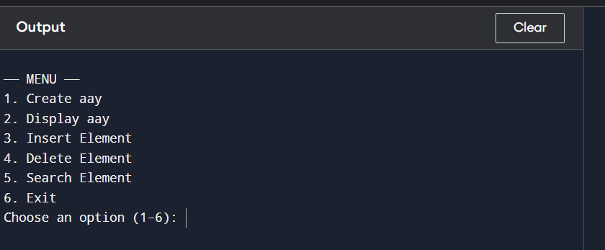

Ques-2)

#include <iostream>

using namespace std;

int main() {

int n;

cin >> n;

int a[100];

for (int i = 0; i < n; i++) cin >> a[i];

int k = 0;

for (int i = 1; i < n; i++) {

if (a[i] != a[k])

{

k++;

a[k] = a[i];

}

else

{

continue;

}

}

for (int i = 0; i <= k; i++) cout << a[i] << " ";

return 0;

}

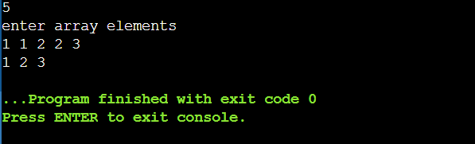

Ques-3)

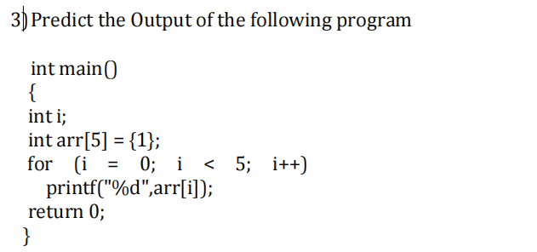

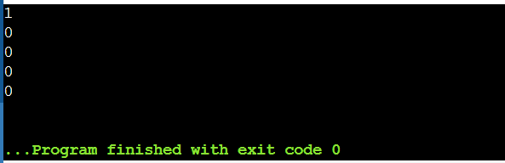

Ques-4)

Reverse-

#include <iostream>

using namespace std;

int main() {

int n;

cin >> n;

int a[100];

for (int i = 0; i < n; i++) cin >> a[i];

for (int i = 0, j = n - 1; i < j; i++, j--) {

int temp = a[i];

a[i] = a[j];

a[j] = temp;

}

for (int i = 0; i < n; i++) cout << a[i] << " ";

return 0;

}

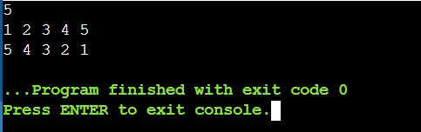

Multiplication-

#include <iostream>

using namespace std;

int main() {

int r1, c1, r2, c2;

cin >> r1 >> c1 >> r2 >> c2;

int A[10][10], B[10][10], C[10][10] = {0};

for (int i = 0; i < r1; i++)

for (int j = 0; j < c1; j++)

cin >> A[i][j];

for (int i = 0; i < r2; i++)

for (int j = 0; j < c2; j++)

cin >> B[i][j];

if (c1 != r2) {

cout << "Invalid dimensions";

return 0;

}

for (int i = 0; i < r1; i++)

for (int j = 0; j < c2; j++)

for (int k = 0; k < c1; k++)

C[i][j] += A[i][k] * B[k][j];

for (int i = 0; i < r1; i++) {

for (int j = 0; j < c2; j++)

cout << C[i][j] << " ";

cout << endl;

}

return 0;

}

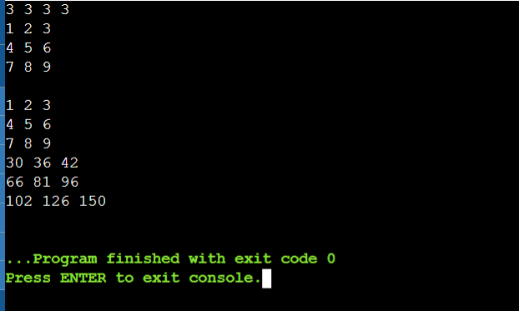c)transpose-

#include <iostream>

using namespace std;

int main() {

int r, c;

cin >> r >> c;

int A[10][10], T[10][10];

for (int i = 0; i < r; i++)

for (int j = 0; j < c; j++)

cin >> A[i][j];

for (int i = 0; i < r; i++)

for (int j = 0; j < c; j++)

T[j][i] = A[i][j];

for (int i = 0; i < c; i++) {

for (int j = 0; j < r; j++)

cout << T[i][j] << " ";

cout << endl;

}

return 0;

}

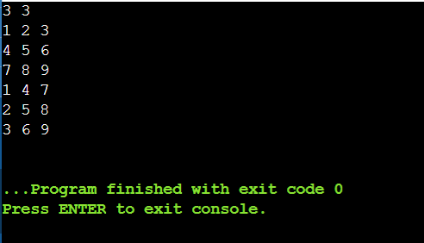

Ques-6)

Sum of all rows individually-

#include<iostream>

using namespace std;

int main()

{

int n,m;

cout<<"enter m and n"<<endl;

cin>>m>>n;

int a[n][m];

for(int i=0;i<n;i++)

{

for(int j=0;j<m;j++)

{

cin>>a[i][j];

}

}

for(int i=0;i<n;i++)

{ int sum=0;

for(int j=0;j<m;j++)

{

sum=sum+a[i][j];

}

cout<<"sum of"<<i+1<<"row is"<<sum<<endl;

}

return 0;

}

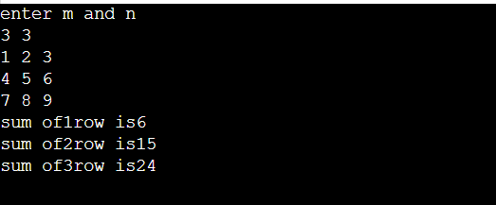

Sum of all columns-

#include<iostream>

using namespace std;

int main()

{

int n,m;

cout<<"enter m and n"<<endl;

cin>>m>>n;

int a[n][m];

for(int i=0;i<n;i++)

{

for(int j=0;j<m;j++)

{

cin>>a[i][j];

}

}

for(int j=0;j<m;j++)

{ int sum=0;

for(int i=0;i<n;i++)

{

sum=sum+a[i][j];

}

cout<<"sum of"<<j+1<<"column is"<<sum<<endl;

}

return 0;

}

